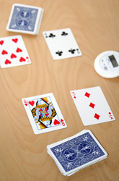
Multiplication Math War
Here are the instructions:
- Pick a partner to play Multiplication Math War.

- Shuffle the deck of cards and deal them face down, giving
each player an equal number of cards until the deck runs out.
Each player keeps their cards in a stack.

- Each player turns two cards face up, reads the number sentence,
and supplies the answer (see card values below). For example, if
your child draws a 5 and a 4, he/she says 5 x 4 = 20. If you
draw a 7 and an 8, then your number sentence is 7 x 8 = 56.
Because your product is larger, you win the four cards and you
put them at the bottom of your pile.

- If each of you has a number sentence with the same product, then
it's war! Each player puts four cards face down and turns up two
of them. The player with the largest product wins the eight cards.

- Play the game for 10 to 15 minutes. When time is up each player
counts his cards. The player with the most cards wins. If one
player runs out of cards before time is up, then the other
player wins.

Card Values
Cards #2-10 = Face Value
Face cards = 11
Aces = 1

HAVE FUN PRACTICING YOUR FACTS!

